ELECTRICAL & ELECTRONICS ENGINEERING DEPARTMENT
School of Engineering & Technology, Sharda University
Power System ENGINEERING

TUTORIAL Sheet - 2

- For the system shown in Fig. 1, find (a) load flow solution, (b) slack bus power, (c) losses in line 1-2 and. (base MVA = 100 MVA).
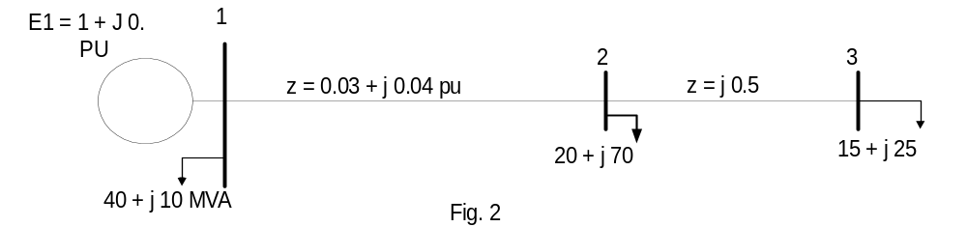

Fig 1
MVA

- For the system shown in Fig. 2, find the load flow solution using (a) Gauss-Seidel method (b) N-R method and (c) Fast Decoupled method. Assume flat start and tolerance as 0.01. Line parameters are expressed in PU.
(base MVA = 100 MVA).
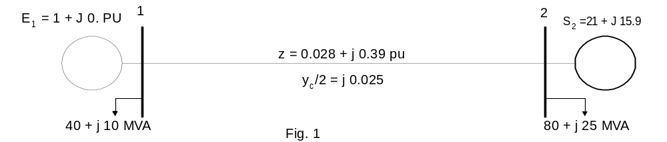
Fig 2
- Consider a three bus system shown in Fig. 3. PU line impedances are indicated on the figure. The generation and load data are given in the Table below. Carry out three iterations of (a) Gauss Seidel method & (b) N-R method for load flow with flat start. Assume the value of acceleration factor. (Base MVA = 100 MVA)

Bus | PG (MW) | Q_{G}  (MVAR) | P_{L}  (MW) | Q_{L}  (MVAR) | V^{Sp}  (PU) | Q_{Gmin}  (MVAR) | Q_{GMAX} (MVAR)
1 |  |  |  |  | 1.00
2 |  |  | 80.0 | 40.0
3 | 60.0 |  | 20.0 | 10.0 | 1.00 | -20.0 | 20.0
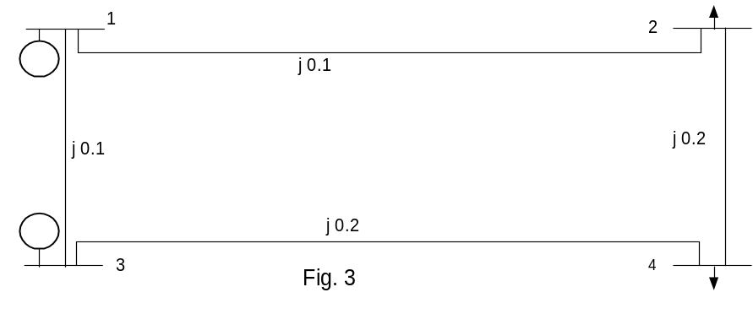

j0.05

